Group 7- **Project 2 Proposal**

Name:

Jordan Myer

Ryan Carnes

John Glendening

Mohammed Alshamsi

Christopher Turner

**Link to our Github repository**

Link to github: https://github.com/JohnGlendening/Project-2.git

**Do vaccines actually work?**

Group 7 chose to expand on project one, which was an analysis of data gathered by several states on COVID-19. For project 2 the team will focus one state to give more detailed analysis on COVID-19 and its impacts. The team will give more visualization to help explain the impacts of COVID 19 on the population and take another look at the data to see if the vaccine roll out has had any positive impact on slowing the number of cases. Please find below the database, formatting, and visualizations we plan to use for project 2.

Database:

* Postgres

Data Frame Formatting:

* JavaScript
* Html
* CSS
* Python Flask
* Pandas

Data Visualizations tools:

* Leaflet
* Plotly

JavaScript Libraries:

* D3
* Amine.js
* Verge3D

Please find a link to the data set below:

<https://api.census.gov/data/2010.json>

<https://data.ca.gov/dataset/covid-19-cases>

<https://data.ca.gov/dataset/covid-19-cases/resource/926fd08f-cc91-4828-af38-bd45de97f8c3>

<https://covidtracking.com/race>

<https://covid.cdc.gov/covid-data-tracker/#datatracker-home>

<https://www.mayoclinic.org/coronavirus-covid-19/map/california>

<https://www.cdc.gov/coronavirus/2019-ncov/vaccines/keythingstoknow.html>?

s_cid=10536:%2Bcovid%20%2B19%20%2Bvaccine:sem.b:p:RG:GM:gen:PTN:FY2

[Vaccination progress data - Coronavirus COVID-19 Response (ca.gov)](https://covid19.ca.gov/vaccination-progress-data/)

[California Coronavirus Map and Case Count - The New York Times (nytimes.com)](https://www.nytimes.com/interactive/2021/us/california-covid-cases.html)

**Visualizations Screen Shots:**

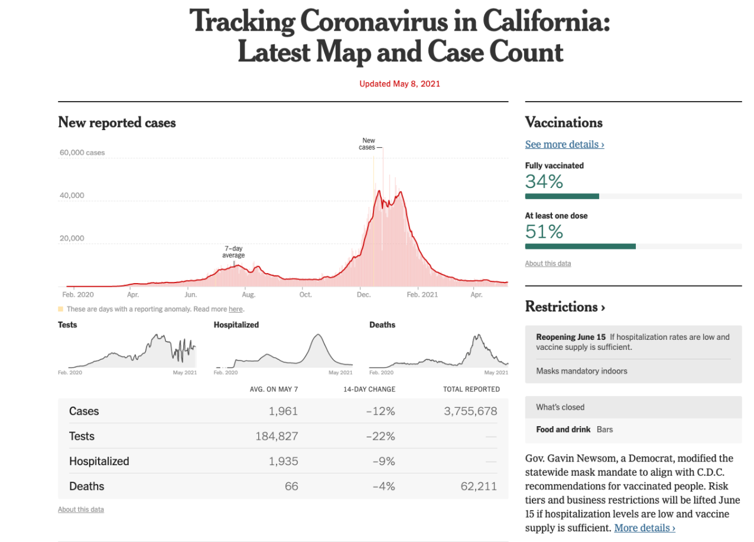

Image 1: Trend showing metrics for California.

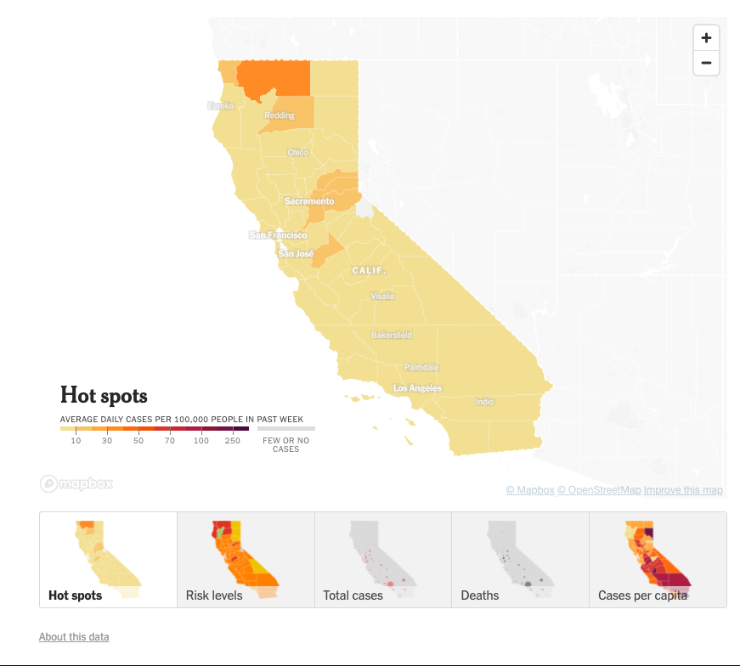

Image 2: Showing concentration of cases in California (heat map or markers)

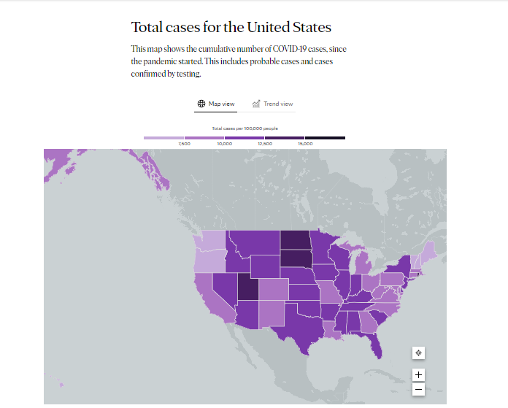

Image 3: Showing heat map of total cases.

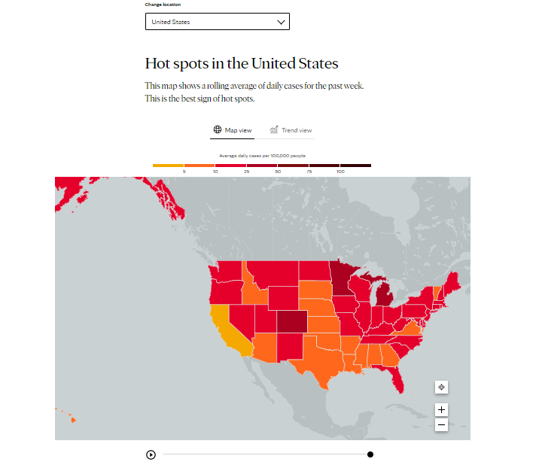

Image 4: Showing confirmed cases hot spots in the US with time scale attribute.